Nodule me Questionnaire Sheet 1.1

Name:

Q1. Are you doctor or radiologist?

YES / NO

Q2.Can you complete to label one nodule in Nodule1 .dcm data?

YES / NO

Q3.Please tell me, where interface is hard for you to use?

Ex) It was hard to understand which is PEN tool.

Ex) It was hard to know if I was in labeling or not.

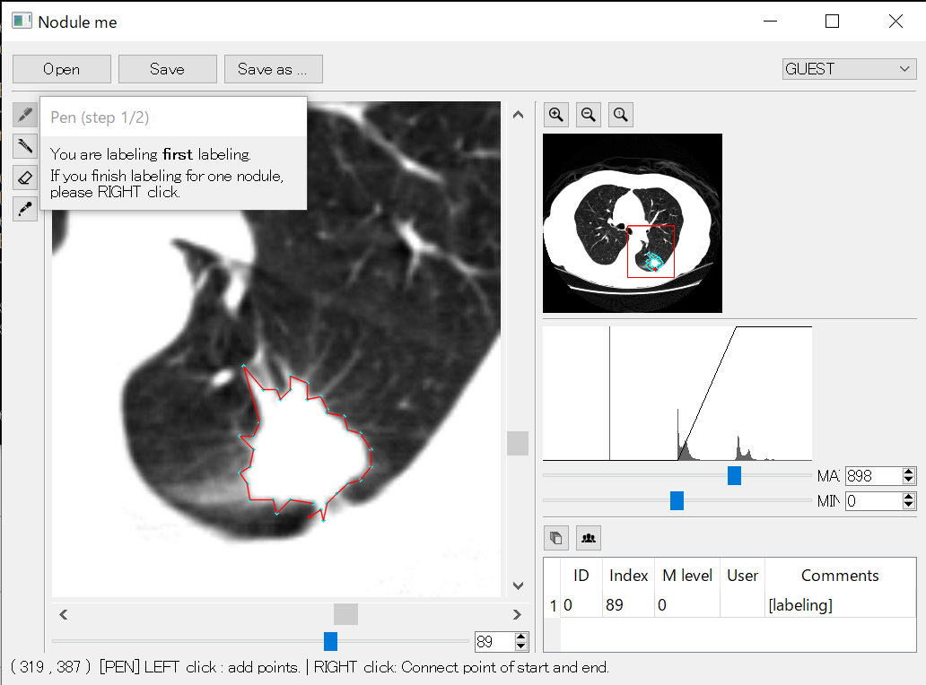

Q4.Please tell me, what function do you want?

Ex)Auto labeling function

Q5.Please give me some comments or advise.